1.3 Sketching: Isometric, Orthographic, Dimensioning and Scaling
Name: _____________________________________________Date:__________Period:___
- What is an isometric sketch?
- What is an orthographic sketch?
- Label the line types shown below:

- Label the line types shown in the drawing below:
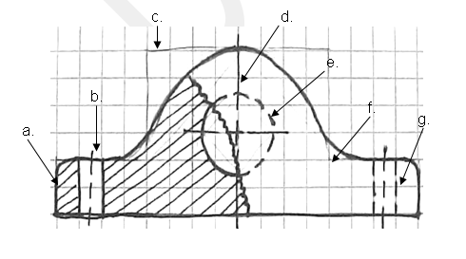 | - _______________ e. _______________  - _______________ f. _______________  - _______________ g. _______________  - _______________
5. Draw the three views of this object, in the correct order, which is _______________________.
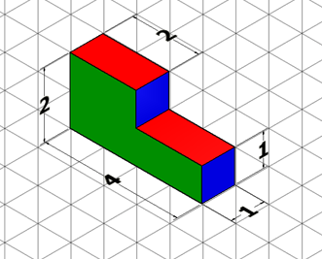
Orthographic Projection Activity 2:
Draw the figure—in 3D—on the isometric graph paper below. Don’t forget to number each problem you sketch. Draw small enough to fit five drawings!
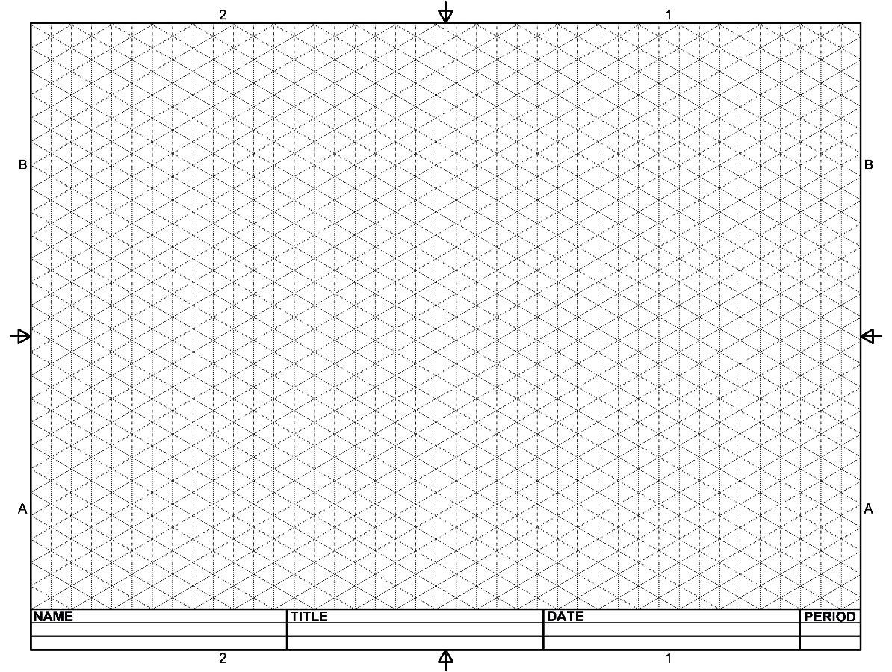
- What are dimensions?
- Follow along as your teacher discusses the presentation on dimensioning guidelines. List the rules or guidelines below.
- Rule 1:
- Rule 2:
- Rule 3:
- Rule 4:
- Rule 5:
- Rule 6:
- Rule 7:
- Rule 8:
- When using ¼ in. graph paper, each square equals ¼ in. or .25 in. Make the following conversions:
1 in. = _______ squares 12 squares = _______ in.
1 ¼ in. = _______ squares 7 squares = _______ in.
2 in. = _______ squares 9 squares = _______ in.
2 ¾ in. = _______ squares 3 squares = _______ in.
- Use the dimensioning guidelines to dimension this sketch. Use extension and dimension lines! Scale is ¼” = 1 square.
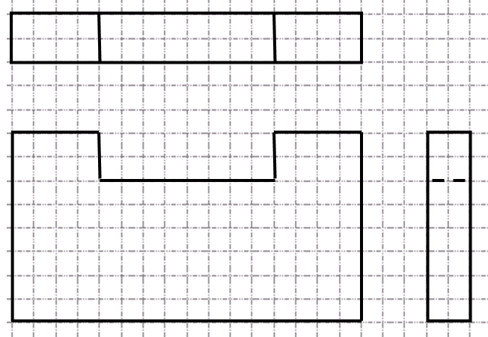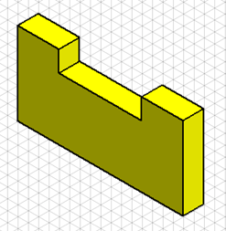
9. Draw the three views of this object to scale, and then add appropriate dimensions.
