Name_____________________________ Pd_______

Name_____________________________

Skimmer
Directions: Use the measurements from this sheet to lay out your skimmer on cardboard. Use the dimensions. The solid lines are cutting lines; the dotted lines represent scoring and folding lines. Quality work and precise measurements will make your skimmer slide easily across a smooth floor.

Decorate your air racer before assembling.
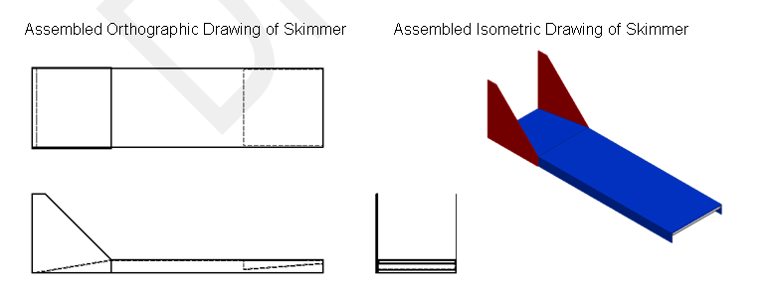

Skimmer Plans:
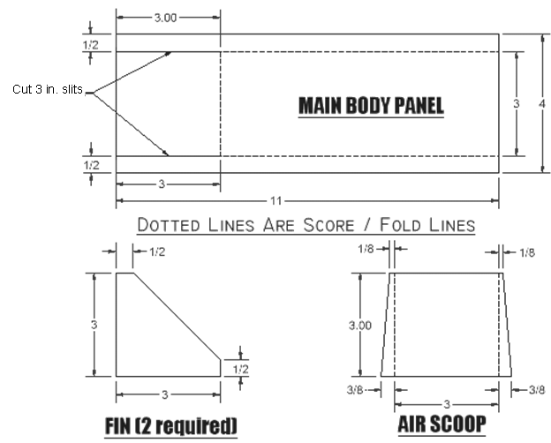

- How did your measuring skills help you build your skimmer?

- How far did your skimmer travel?

Distance in FT
Test 1 Test 2 Test 3
- Explain why your skimmer was more or less successful than your classmates.

- Write a paragraph on how you will use teamwork in your future career? 5 sentences!

